Multicam Studio Quick Start
User is required to know the camera operating mode or set the camera operating mode and other parameters first before starting the Multicam Studio.

Step 1
After installation of the MultiCame driver, create the shortcut from C:\Program Files (x86)\Euresys\MultiCam\Bin

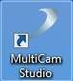

Step 2
Double-click on the shortcut icon. The Multicam Studio will start up.

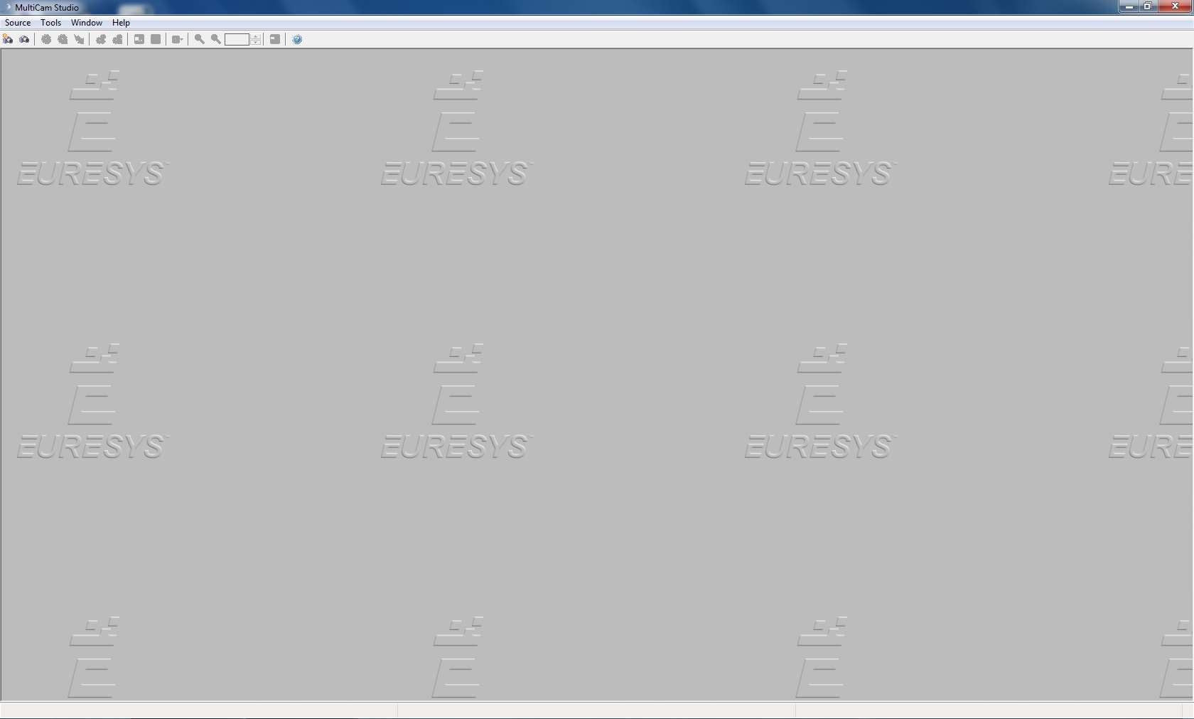

Step 3
Click on the 1st icon to create a new source.

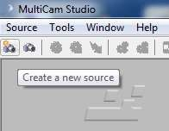

Step 4
The Source Setup Wizard dialog starts up. Select Camera source type accordingly.

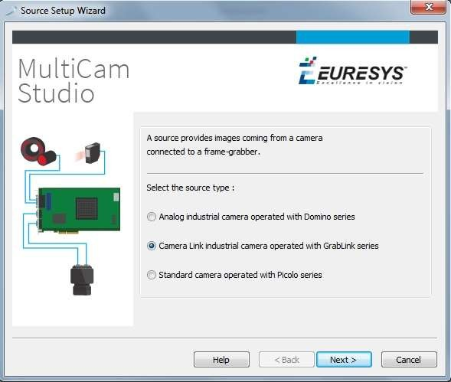

Step 5
Select the camera brand and model

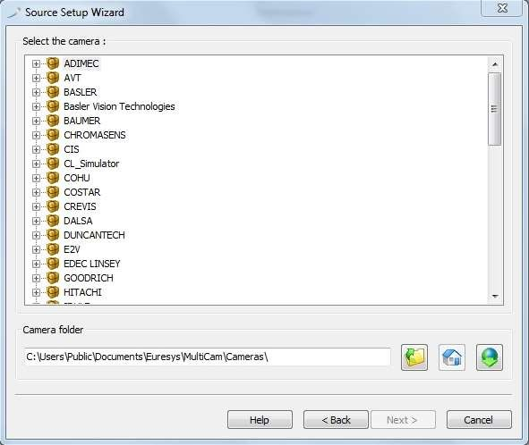

Step 6
Select the camera operating mode
User is required to know the camera operating mode or set the camera operating mode first. Example, Synchronous or Asynchronous Reset mode

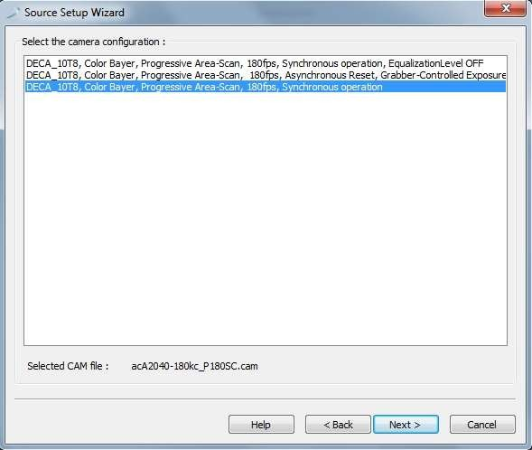

Step 7
Select the Topology MONO, MONO_DECA, or MONO_SLOW and Connector Type as Required. Refer to documentation under BoardTopology for details.
Click on the Finish button to complete setup.

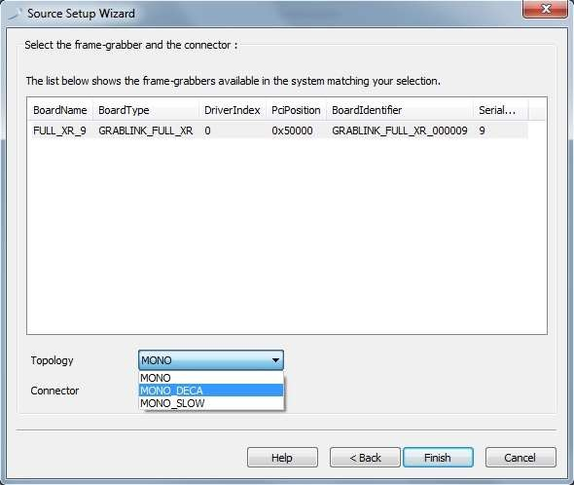

Step 8
Multicam Studio UI after completion of setup.

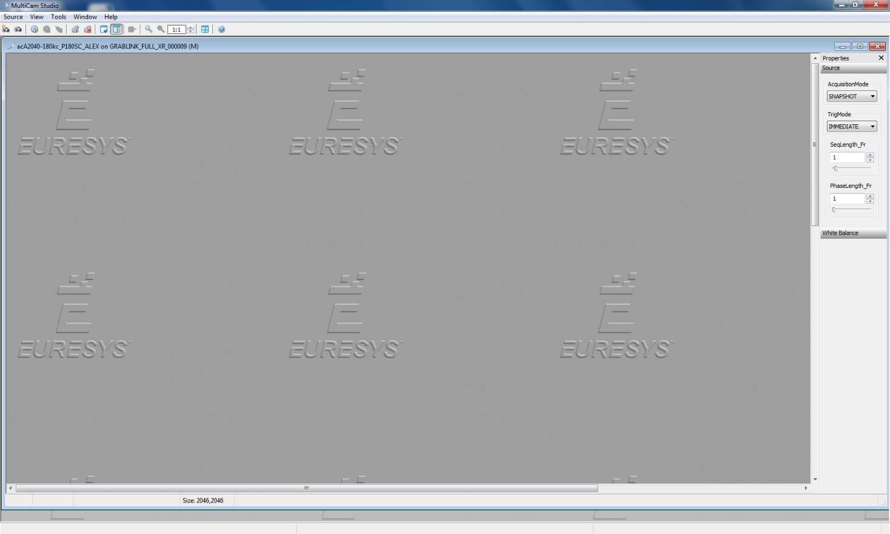

Setting Up for Virtual COM Port in Multicam Studio
Some cameras require a COM port to be setup to communicate with the frame grabber.
This creates a virtual COM port and is associated with the serial link associated with camera connector A (Domino Symphony, Grablink Expert 2) or M (Grablink series).

This is only available under Windows. It requires the user who runs the application to have administrator privileges. Moreover, under Windows Vista and later, the application must be explicitly run as administrator.

Step 1
Run Multicam with administrator rights

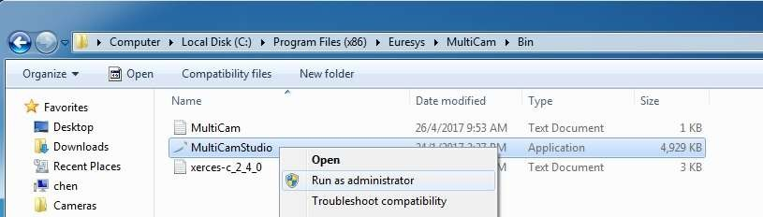

Step 2
Select Tools->Board Information

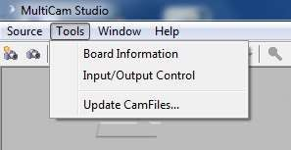

Step 3
Set the virtual COM port number

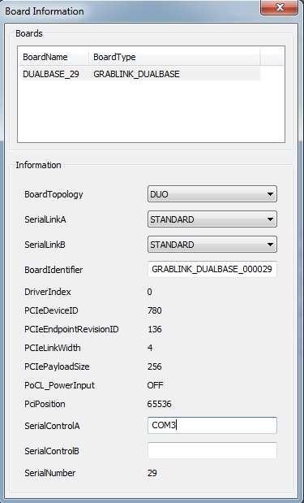

Camfile

Digital Area Scan filename syntax

Example Camfile : A501kc_P74RG.cam
- General form : <Model>_<Scan><Rate><CamMode><ExpMode>.cam

Identifier | Possible values | Example value
<Model> | - | A510kc
<Scan> | I: interlaced scan  P: progressive scan | Progressive Scan
<Rate> | - | 74 frame per second
<CamMode> | R: asynchronous reset operation  S: synchronous scanning | Asynchronous reset
<ExpMode> | G: grabber-controlled exposure  C: camera-controlled exposure | Grabber-controlled exposure

Line Scan filename syntax
- Example Camfile : spL4096-39kc_L4096RG.cam
- General form : <Model>_<Scan><Size><CamMode><ExpMode>.cam

Identifier | Possible values | Example value
<Model> | - | spL4096-39kc
<Scan> | L: Line scan | Line Scan
<Size> | Number of pixels per line | 4096
<CamMode> | R: grabber-controlled line rate  S: free running | Grabber-controlled line rate
<ExpMode> | G: grabber-controlled exposure  C: camera-controlled exposure P: permanent exposure | Grabber-controlled exposure

I / O Check using Multicam Studio
Step 1
Select Tools->Input / Output Control



Step 2

To check the IO Input:
- Please enable the checkbox Automatic. (See below figure)
- Under Input, select IIN1 (or any input pins you are interested in or signals connected to)
- Under the Config of Input, select SOFT (See below figure)
- When you trigger the input, the State should change.

Please Note: All input pins need to configure the Config to SOFT individually.

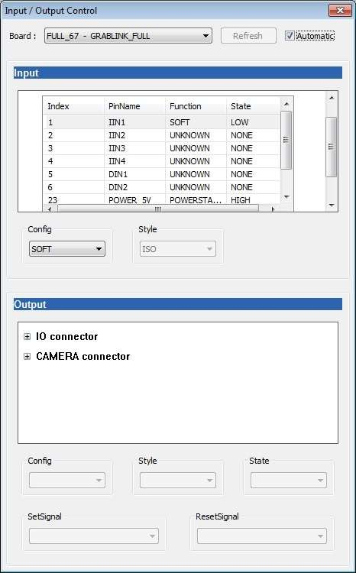

Multicam Studio Properties, Expert View and Save feature

In Multicam Studio, open a cam file of your choice, click on the Properties button. A Properties dialog box will appear.
Click on the Expert View button.
Now, the full list of parameters will appear for each category.
There is a Save button if you are using Multicam version 10 and above. This enables you to save your changes to the parameters.

